
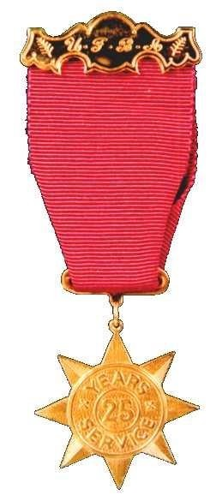
Website www.Canterburygoldstar.co.nz
Facebook : canterburygoldstar
Email : canterburygoldstar@gmail.com

Canterbury Fire Brigades Gold Star Association

The Canterbury Fire Brigades Gold Star Association consists of over 300 serving and retired fire service personnel who are recipients of the United Fire Brigade’s Association of New Zealand 25-year Gold Star award.
Objectives of the Association.
- The objectives of the Association shall be to create a bond of friendship and foster a close liaison between all members and kindred organisations.
- To welcome all Gold Star recipient’s resident in the Canterbury Province, to our Association.
- Promote sporting or other fixtures to generally promote and assist the interests of all members.
Membership.
- Membership shall be open to all recipients of the 25-year Gold Star, as presented by the United Fire Brigades Association of New Zealand (“UFBA”) who are resident in the Province of Canterbury.
- Application for membership to the Canterbury Fire Brigades Gold Star Association shall be made on the approved form which can be found on our website, and shall be conditional on confirmation by the members Brigade Secretary or Chief Fire Officer.
- Transfers to or from other Gold Star Associations, may be arranged, provided the members subscription is current.
- The official lapel badge can only be obtained from the Secretary and/or Treasurer of the Association.
Subscriptions
- The subscriptions shall be decided at every Annual General Meeting. Subscriptions shall cover the period 1st April to 31st March each year. Currently set at $10.00 per year.
- Members owing more than 2 years of Subscriptions, will be removed from the roll.
- To become a Member you must apply for Membership and the required forms are available on our website. http://www.canterburygoldstar.co.nz/forms

P.U.M.S. (Paid Up Membership scheme) Information is available from the Secretary.
- These subscriptions will be calculated at $1.00 per year less than the yearly subscription, set at the time of applying to join this scheme and up to a maximum of 75 years of age. Check to see if your Brigade pays for your membership, a few Brigades do.
- Any Gold Star Member reaching the age of 75 years, shall not be required to continue to pay their Annual Subscription, as from 1st April 2018.
50 Year Gold Stars
- If you are fortunate enough to serve for 50 years and you apply to the U.F.B.A. for this medal, you will be presented with a U.F.B.A. 50-year Gold Star by the U.F.B.A.
- In addition to the U.F.B.A. award the Canterbury Fire Brigades Gold Star Association, if invited, will present you with a 50-year C.F.B.G.S.A. Lapel pin and your Partner with a 50-year Brooch/Pin. These items also need to have been applied for from the Secretary of the Canterbury Fire Brigades Gold Star Association.
- A point to remember, is that a recipient wishing to receive a 50-year Lapel Pin and a 50- year Brooch must have been a continuous member of the Canterbury Fire Brigades Gold Star Association, from the initial 25-year Gold Star presentation.
- At a recent Executive Meeting of the Association, it was moved that for People who had received a 25-year Gold Star and were a Member of the Association and who had lapsed their membership, an option is there now to re-join and pay all of the outstanding subscriptions.
- The facility to buy back your membership of the Association will cease at the Annual General Meeting in May 2022. Thereafter, you will not be able to receive a Lapel Pin or Brooch from the C.F.B.G.S.A. until you have completed 25 years as a financial member of our Association.
Organisations and Awards
- Fire and Emergency New Zealand. Presents recipients with the 14-year Long Service and Good Conduct Medal and associated 7-year clasps.

- The United Fire Brigades Association. Presents recipients with the 3-year Certificate, 5-year medal, associated 2-year bars, 25-year Gold Star medal and associated 2-year bars, 50-year Gold Star medal and associated 2-year bars.

- Canterbury Provincial Fire Brigades Association. This Association organises Fire Brigade competitions and present successful competition winners with various trophies.

- Canterbury Fire Brigades Gold Star Association. Presents 25-year and 50-year Gold Star recipients with Lapel Pins and Partners Brooches/Pins. It also promotes the bond of friendship, sporting activities, gatherings and welfare of its members.

- On the event of your Gold Star presentation our Gold Star Association, if invited, will present you with a 25-year pin and your Partner with a 25-year Brooch/Pin. These have to be applied for.
- The United Fire Brigades Association ( UFBA) and Canterbury Provincial Fire Brigades Association (CPFBA) and Fire Emergency New Zealand ( FENZ) are all associated with presenting a Gold Star and an application must be made to them by your Brigade Secretary.

- At the recipients 25-year Gold Star function, they and their partner are welcomed to the Canterbury Fire Brigades Gold Star Association and are presented with a lapel pin and the partner with a brooch/pin. With the introduction of the 50-year medal the Association recognises this with a 50-year lapel pin and 50-year brooch/pin providing these have been applied for.

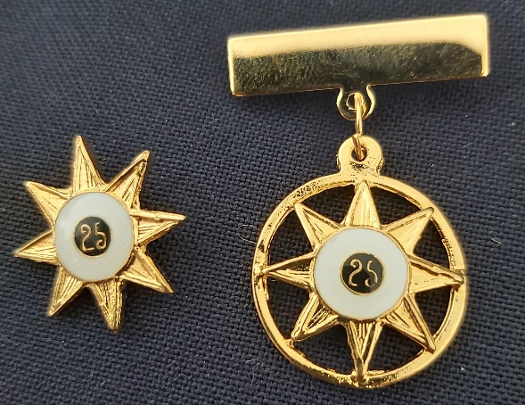

- The Gold Star Association has no financial connection to the UFBA nor CPFBA or FENZ.

Contact

All application forms are available on our website. http://www.canterburygoldstar.co.nz/forms

Greg Woodhouse
Canterbury Gold Star Association
Secretary / Treasurer

canterburygoldstar@gmail.com
or
admin@canterburygoldstar.co.nz

